Assignment 1 ROS

Rafal Grasman

Menno Broeders

**Running our code**

**This document assumes that ~/ros_workspace/ is in your ROS_PATH variable!**

Extract the zip into ~/ros_workspace/

*Detect the package:*

rosdep update

(if needed, run rosdep init beforehand)

*Build the binary:*

cd ~/ros_workspace/assignment1

rosmake

*Then launch the package:*

roslaunch assignment1 assignment1.launch

*Send a draw triangle command:*

rostopic pub /turtlesim1/draw_triangle/cmd assignment1/Triangle <sideLength> <clockwise>

(<sideLength>(integer) and <clockwise>(true/false) should be adjusted accordingly)

Ctrl+C to exit and try different values/directions

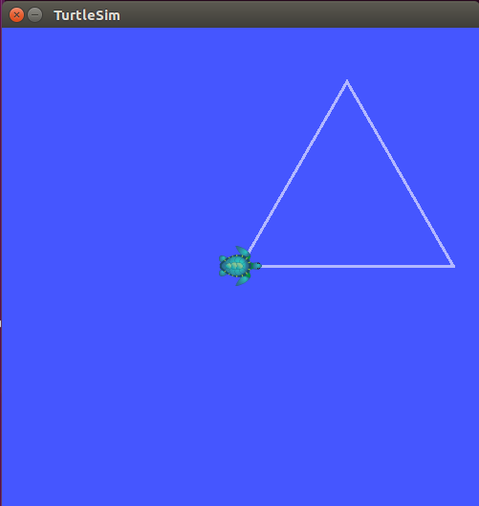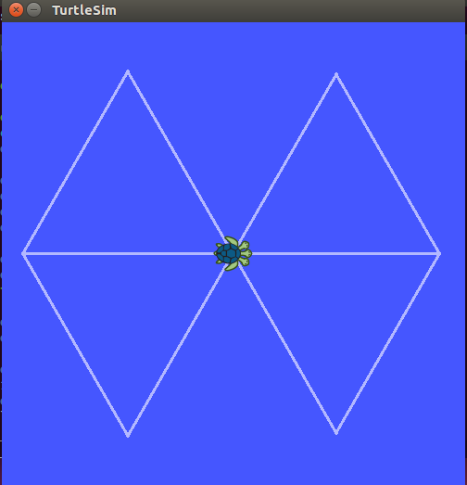

**How it works**

The RQT graph looks as follow:

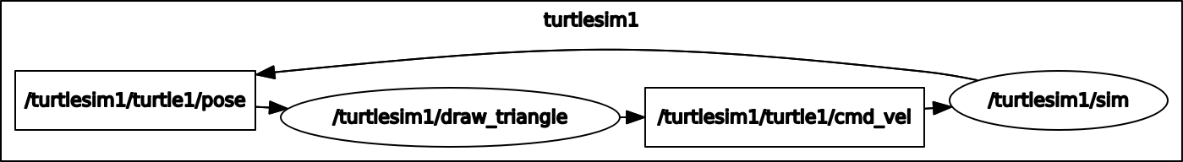

The assignment1 package subscribes to turtle1/pose messages to get information about the position and angle of the turtle, then publishes messages to turtle1/cmd_vel to modify the movement. The package receives the triangle parameters and command on turtlesim1/draw_triangle/cmd (subscribed to that topic) when something publishes to it.

To determine and adjust the side length, first each 3 points of the triangle are calculated and bounded within range of the drawing box. Then the drawing is performed with the shortest length result from the bounding.